**Highland West Stake**

**Young Men**

**Aaronic Priesthood Encampment**

**2018 Leader Guide**



**Held at Lost Eden, AZ**

**May 29 through June 2, 2018**

# ***Quick Start Information***

* Camp Dates:
  + For Deacons, camp runs May 29 through June 2. Please arrive at camp Tuesday, May 29, between 5 pm and 7 pm.
  + For Teachers and Priests, camp runs May 30 through June 2. These young men should arrive at camp the afternoon of Wednesday, May 30.
* Several Merit Badges offered at camp have prerequisites which must be satisfied before coming to camp. Failure to provide evidence of the prerequisites for any Merit Badge will result in a ‘partial completion.’
* Everyone in camp must have a completed BSA Health and Medical Record Form with Parts A, B, and C completed. For the youth, part C must be completed by a medical professional. A parent or guardian must sign Part A, page 2 to allow any medications, including over-the-counter medications, be given to their child.
* All adults in camp must have completed Youth Protection Training as well as Hazardous Weather Training. This training may be taken online at my.scouting.org.
* **AT LEAST TWO YOUTH PROTECTION TRAINED ADULTS MUST BE WITH YOUR UNIT AT ALL TIMES**.
* Camp sits at 6,500 ft. above sea level. All adult participants should be capable of walking in this environment during their stay in camp.
* Campers should not come to camp if they exhibit flu-like symptoms in the 7-day period prior to camp: fever of 101 degrees or greater or if they have a cough or sore throat. This includes vomiting within 36 hours of coming to camp.

# 

## **Planning Ahead for Camp**

## March

* Begin planning by considering each Scout’s interest and advancement needs. Have the scouts prioritize the available merit badges in three groups: the water badges, the shooting and horsemanship badges, and the remaining badges. Merit Badge pre-registration is required.
* **Before April 1**, provide the Stake with a roster of all boys and adults who will be attending camp. Use the Youth Roster and Adult Roster forms from the Encampment web site.

## April

* The deacons should plan opportunities to work on merit badge prerequisites.
* Ensure that each young man has made arrangements for completion of the medical form including a full physical examination (part C).
* Provide each young man with a personal equipment list.
* Meeting for quorum presidents.

## May

* Finalize camp program plans and advancement needs.
* All physical examinations (including Part C) should have been completed and collected by the ward.
* The Scout Committee should finalize the ward food and transportation plans.

## A Few Days Prior to Camp

* Senior Patrol Leader should conduct a personal pack, gear, and uniform inspection.
* Ward and patrol equipment should be ready for packing.
* Scout Committee should make final checks on transportation.

## **Registration**

To be eligible for camp, youth must be 12 years old or older before June 30, 2018. Camp is open to youth living within the boundaries of the Highland West Stake, both members and non-members. Turn in all registration materials by April 1, 2018.

To register for camp, email an electronic copy of the Youth Roster to the Stake showing birth date, age, and t-shirt size (and merit badge preferences for each deacon; be sure to indicate any badges already earned) **before April 1**. Print as many sheets as needed for your youth and adults to turn in upon arrival at camp.

In addition, the following forms are required by May 1. Check off each of the required forms as they are collected and turn in all forms to the Stake.

1. BSA swim check form for youth and adults who plan to participate in any water activity (such as the swimming or canoeing merit badges). The swim check must be done prior to camp. Those not tested can still participate in fishing at Lake Mary.
2. BSA medical form parts A, B, and C for each young man and adult
3. Troop medication list (list of prescription medications needed by any youth)
4. Signed parent permission form for each young man
5. Signed Horsemanship Waiver

## **Directions to Camp**

From Gilbert, find your way to Highway 87 North toward Payson. In Payson, continue on Highway 87 toward Pine. Pass Pine and Strawberry, turn left on Lake Mary Road at Clints Well, AZ. Follow Lake Mary Road for 6.9 miles to Forest Road 211 (Google Maps says it’s FR81 but the signs say FR211), turn right. Continue on FR211 for 6.6 miles. Turn right at FR211‑F and follow signs to camp. FR211 winds through the forest with twists and turns – but, if you have to make a choice, *stay on the straight and narrow path*. Lost Eden is located at 34.637093, -111.251189.

## **Directions to Lake Mary (all water activities)**

From camp, make your way back to FR211 and turn left (west). Follow FR211 to Lake Mary Road and turn right. Follow Lake Mary Road for 35 miles. Lake Mary is located on the left side of the road. Meet at the public boat ramp. Lake Mary is about a 50 minute drive from camp.

## **Directions to Blue Ridge Fire Station (service project)**

From camp, make your way to FR211 and turn right (east). Follow FR211 to Highway 87 and turn left. Follow 87 for 5 miles. Turn right on Enchanted Gardens Lane. The Blue Ridge Fire Station is about a 20 minute drive from camp.

## 

## **Map of Camp**

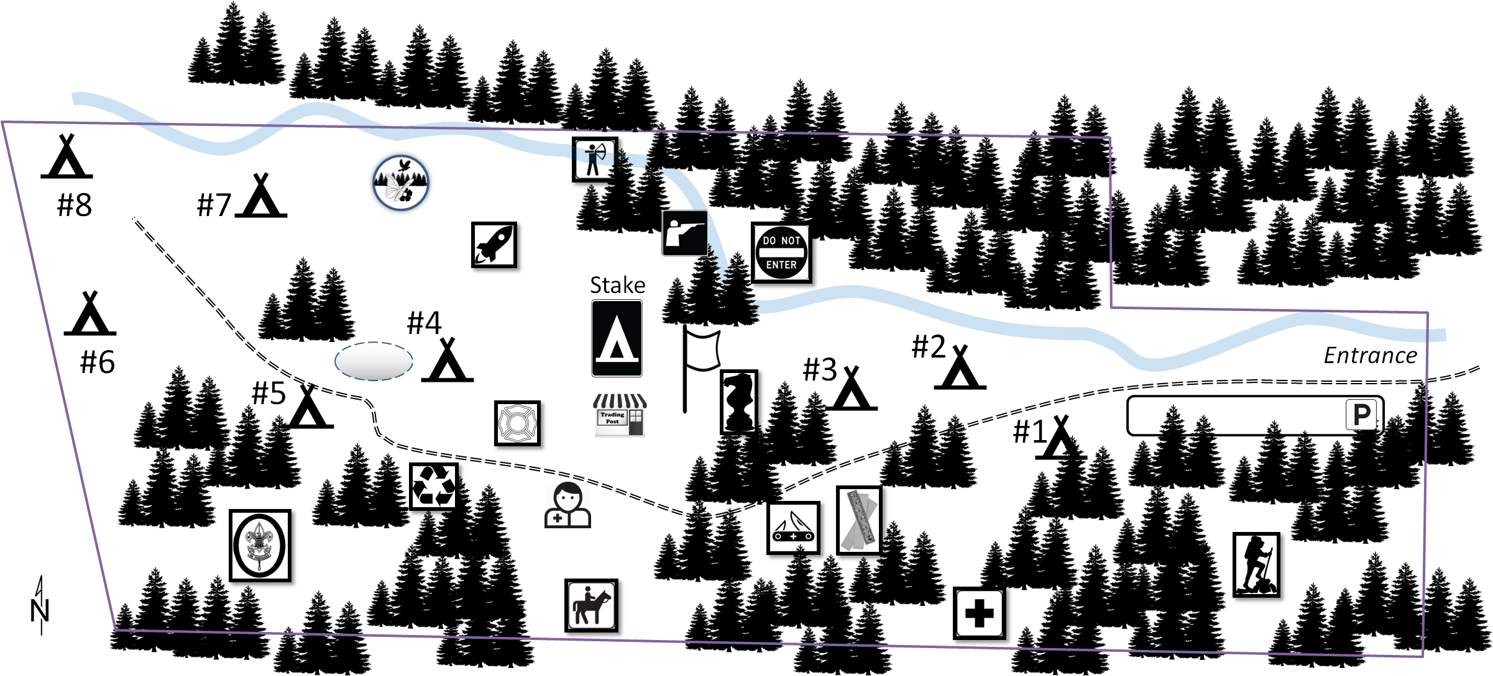

Legend:



1. 6th Ward

2. Constellation

3. Sierra Madre

4. Pioneer

5. Morrison Ranch

6. Highland Park

7. 3rd Ward

8. Higley Groves

 Parking area

 Wilderness Survival

 First Aid

 Woodcarving

 Leatherwork

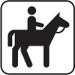 Horsemanship

 Medical Cabin

 Environmental Science

 Space Exploration

 Emergency Preparedness

 Chess

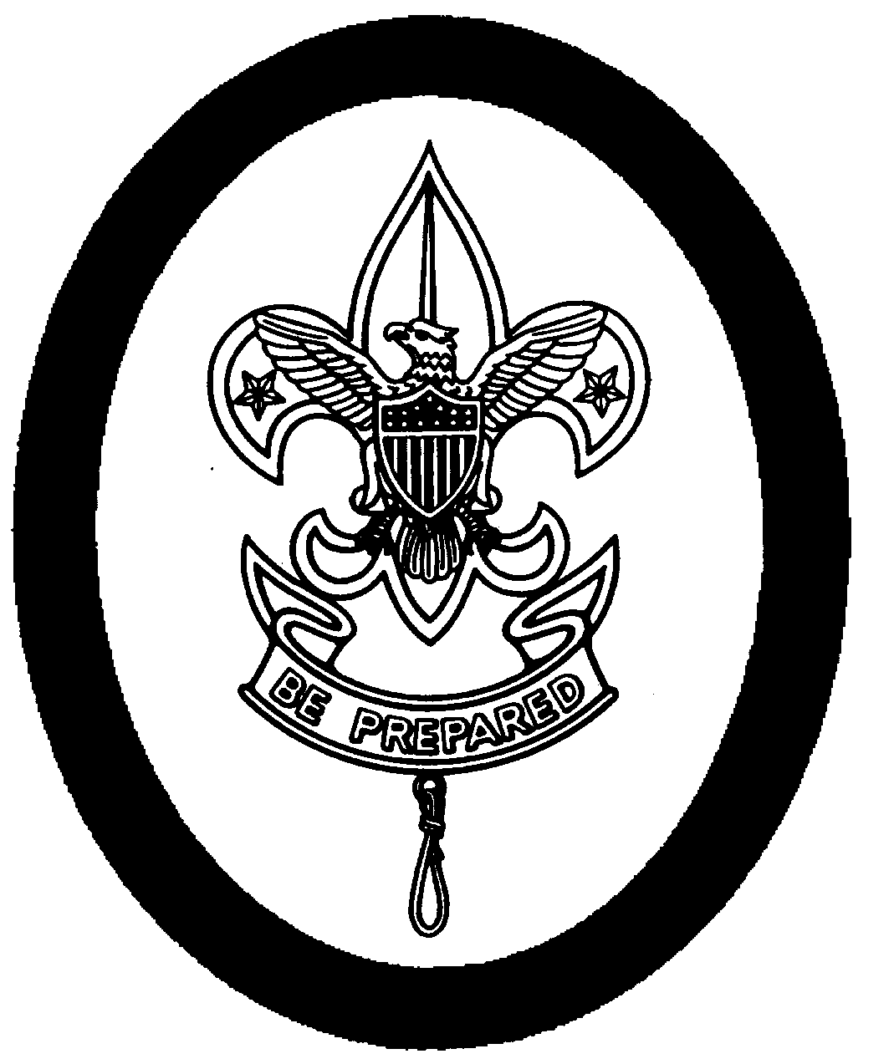 Trail to First Class

 Archery

 Rifle Shooting

Nature



 Trading Post

 Flag Pole

## 

## **Arrival at Camp**

For deacons, check in time for camp is between 5 PM and 7 PM on **Tuesday, May 29**. Teachers and priests will check in at camp before 5:30 pm on May 30.

1. Upon arrival, you will be greeted at the property gate by a staff member who will direct you to your assigned campsite.
2. Once your equipment is unloaded, drivers will return their vehicle, including trailers, to the parking area near the gate. No vehicles are allowed to remain at your campsite. All vehicles are to be parked in the designated area near the entrance gate. This is due to Forest Service fire restrictions.
3. The Senior Patrol Leader will oversee camp setup.
4. After setup, the scoutmaster should spend some time with the deacons reviewing the schedule provided by the Stake. If there are any major conflicts between badges they really wanted, the scoutmaster should to talk to the Stake. If not already done, deacons should fill out merit badge blue cards at this time.

## **Tuesday Evening Schedule**

* Pickup t-shirts at the Trading Post (if not already received)
* If your ward plans an evening meal on Tuesday, please complete the meal and cleanup before 7:15 pm.
* The Stake will provide a dessert for all wards at 7:30 pm Tuesday night. A cracker barrel meeting for deacon quorum presidents and scoutmasters will be held at 10:00 PM at the Stake tepee.
* Lights out – 10:30 PM

# 

***Introduction to Camp***

## Camp Theme: “Look Up!”

Our camp theme is from an October 2011 General conference talk, “It Is Better to Look Up,” by Carl B. Cook of the Seventy. Elder Cook describes a conversation with President Thomas S. Monson at a time when Elder Cook was feeling overwhelmed: “He smiled and lovingly suggested, while pointing heavenward, ‘It is better to look up!’” Elder Cook extended that lesson to all of us, that we should always strive to look to the Savior, especially when we are feeling overwhelmed. He concluded with this testimony: “We are Heavenly Father’s children. He wants to be a part of our lives, to bless us, and to help us. He will heal our wounds, dry our tears, and help us along our path to return to His presence. As we look to Him, He will lead us.” (<https://www.lds.org/general-conference/2011/10/it-is-better-to-look-up?lang=eng>)

## Schedule

To provide a meaningful long-term camp experience for the deacons, our Aaronic Priesthood Encampment will begin on Tuesday night, May 29 and will conclude in the late morning on Saturday, June 2.

For the deacons, camp will include merit badge work typical of a BSA camp during the morning hours on Wednesday, Thursday, and Friday. In the afternoons, each deacon will be assigned to one of three groups for an activity each day. The three afternoon activities are

1. A service project at the Blue Ridge Fire Station
2. A trip to Lake Mary for the Swimming, Canoeing, or Fishing merit badges
3. An afternoon in camp working on ~~Rifle Shooting,~~ Archery, or Horsemanship merit badges. Forest Service fire restrictions forbid rifle shooting. We will have an alternative activity for young men who were scheduled for that merit badge.

Note that deacons will not be grouped by ward. Because of different merit badge priorities, we’ve had to mix things up.

Saturday morning, while the teachers and priests are working on their service project, the deacons will have a game of Capture the Flag. This will also be the time for Stake and ward leaders to finish any paperwork related to merit badges.

## Merit Badges and Activities

In total, camp will offer 15 different merit badges. Current merit badge requirements are available in the 2018 Requirements book available at the Scout Shop. Blue merit badge cards are available at the Trading Post for purchase.

Merit badges are scheduled at specific times during the day. During morning hours, scouts should expect to attend each merit badge class twice. Advance sign-ups are required. Scouts sign up for merit badges many weeks ahead of camp by providing a ranking of the available badges. If there is a maximum enrollment for a class, enrollment will be randomly assigned among those most interested in the badge. If needed, you can speak with one of the merit badge area chairmen to find an alternative. We will try to be flexible enough to help you meet your goals despite our schedule. Each troop will provide blue merit badge cards for their Scouts. Scouts are required to bring blue cards with them to their first day. Assist your Scout by ensuring that prerequisites are complete before camp. We want to avoid any partials.

It won’t be possible for any scout to earn more than about five or six merit badges. It might be possible for a scout to earn two of the three badges offered at Lake Mary, but unlikely that he’ll earn all three. The same is true for the afternoon badges offered in camp. Most young men should be able to earn four badges offered during the morning hours. Some young men will choose to work on Trail to First Class instead – this will reduce the number of merit badges earned, but will still help scouts progress toward rank advancement.

## Trail to First Class Advancement Program

The “Trail to First Class” program caters to both Scouts needing only a single requirement and Scouts needing everything. We are willing and eager to teach any skills a scout may want to know for advancement purposes. Scouts should bring their Boy Scout Handbook (or Scoutbook report) on the first day so we can record their current information on our tracking sheets. “Trail to First Class” is also a great place for adults to help out by volunteering to teach a skill in which they are proficient.

## Service Project

For a few hours on an assigned afternoon, scouts and leaders will have an opportunity to participate in a service project. The project is located at the Blue Ridge Fire Station, about 10 miles east of camp (<http://www.brfdaz.org>; please do not contact them directly, our point of contact is Michael Bowen, 480-427-8290). After lunch on each day the group assigned to the project for the day will meet at the parking area. The assigned drivers will fill their vehicles with an appropriate number of young men and follow the lead car to the fire station. The fire chief or fire fighter will then orient us to the project for the day. The designated drivers become youth supervisors during the service project. Their responsibilities are centered on safety, inclusion, encouragement and general supervision and clean up. After the service project the fire station will finalize the day with some fun/education. The youth will return with the same driver and automobile in which they came. Any free time back at camp should be used to rest and relax until the evening program.

The young men and the adults will need the following:

* long sleeve shirts
* long pants
* well fitting leather working gloves
* hat (recommend wide brimmed)
* safety eye wear (provided by the stake)

Each person will also need 1-2 water bottles. A water fill up station will be provided. If needed, we’ll also provide basic first aid; but fear not, we are on the fire station property!

The benefits of this activity are many!! Of course, it’s a great opportunity to serve! In addition, this project may help with a number of scouting requirements such as:

* Service hours needed for all ranks
* Life rank – this is a “conservation-related” service project that Star scouts need
* Fire Safety merit badge #11 – visit a fire station
* Citizenship in the Community #6 – tell how taxpayer funded services benefit the community
* Forestry #5c – take part in a forest-fire prevention campaign
* Forestry #7c – describe what you should do if you discover a forest fire and how a professional firefighting crew might control it

# ***Good to Know Information***

## Blue Cards

Wards should plan to have enough blue cards on hand to meet the needs of their youth. These should be filled out ahead of time, Tuesday evening at the latest, and turned in to the class instructor/counselor at class on Wednesday. If needed, you can buy extra blue cards at the Trading Post.

Ward packets will be distributed Saturday morning to Scoutmasters. When picking up the packets, please check to confirm that all of our paperwork matches your records. Area directors will be available to discuss any inconsistencies.

## Campsites

The heart of the camp is the ward’s campsite. Please keep it clean and tidy with no trash on the ground and personal belongings put away unless in use. Show your scout spirit by creating a marked entrance and boundaries of your campsite. Display your troop and patrol flags. Create a display board recognizing young men who lead the troop following camp Trail Markers.

## Campsite Fire Restrictions

Forest Service fire restrictions prohibit all traditional campfires. ~~The land owner has asked that our camp have only one fire and that it be managed by the Stake, and then only if not banned by Forest Service fire restrictions.~~ No ward campfires are permitted. If the US Forest Service deems fire conditions high, there may be a ban on all open fires. No charcoal cooking is permitted. Propane cooking equipment is allowed as long as the flame can be turned off at any time. Likewise, **a ward could use a propane fire pit or a battery-operated lantern for their campfire**. Even when a propane stove or device is used, the area under the device must be cleared of any combustible material. No combustible material is permitted within three feet of the device (above or to the side).

## Emergency Procedures

Within the first 24 hours of camp, there will be an emergency procedure drill. This is to inform everyone what the policies and procedures are for camp. Each Scoutmaster must do a head count of their entire ward, including adults. The Stake will take roll to ensure all persons are accounted for. Instructions will follow.

In the event of an emergency in camp, the camp emergency siren will sound continuously calling all persons in camp to the flagpole. Emergencies can include missing persons, fire, or another dangerous situation.

Report all unplanned fires, intruders or other emergencies to the Stake.

If the camp is evacuated, ALL will meet at the Happy Jack Lodge parking lot on Lake Mary Road. Roll call will be taken again.

Evening Activities and Free Time

Short periods of personal or free time can be necessary for each of us. However, wards should plan structured activities during the “Ward Activity” hours. For example, the young men can prepare and conduct a campfire program, including both humorous/entertaining and spiritual elements (could fulfill a requirement for the Communications merit badge). Evening hours could be spent preparing for the next day or working on merit badge requirements. Please do not miss this opportunity to reflect on the day and the eternal principles that could be highlighted for your youth.

Plan time at camp to hold ward or quorum scripture reading or time to work on an element of Duty to God.

## Firearms

No firearms are allowed in camp ~~other than those used in the Rifle Shooting merit badge. All shooting activities are limited to the rifle range, and only when authorized and qualified staff are present.~~

## Flag Ceremonies

Camp-wide flag ceremonies will be held in the morning and in the evening. All young men should be in their Class A uniform for these ceremonies. After the flag ceremony, the staff will provide some very important bulletins about camp that day. Please have your youth lined up at the flagpole so the ceremony can start on time.

Responsibility for flag ceremonies as assigned to the wards by the Stake. If your troop would like to practice their flag ceremony, please contact the Stake.

Suggested outline for a flag ceremony:

1. MC calls camp to order
2. Color Guard raises/lowers the US flag
3. Opening prayer for the day
4. Offer a patriotic message (2 minutes)
5. Turn time to Camp staff for announcements

Flag Ceremony assignments:

* Wednesday morning – Higley Groves
* Wednesday evening – Constellation
* Thursday morning – Pioneer
* Thursday evening – 3rd Ward
* Friday morning – Sierra Madre
* Friday evening – Highland Park
* **Saturday morning – 6th Ward**

## 

## Individuals with Disabilities

Please tell the Stake at registration if anyone in your ward has special needs. Let’s work together to make camp a great experience for everyone.

# 

## Lost & Found

Valuable items should always be boldly marked so that they can be returned if found. Found items should be taken to the Trading Post to be claimed by their owners. Items of high value must be claimed with an adult leader present. At the end of the camp, all lost and found items not claimed (including items left in camp when young men leave) will be taken to the Stake Center where they will wait to be claimed. If items are not claimed by August 15th, they will be donated to Deseret Industries.

## Meals

Wards are responsible for providing their own food. The Stake will prepare and serve the Friday evening dinner.

While we encourage quorums to be boy-led, including meal planning, preparation, and cleanup, please keep in mind the time required and the camp schedule. Consider meals that are quick to prepare with minimal cleanup. Plan to have the necessary adult support to enable the young men to fully participate in the planned camp activities. *This camp may not be the best opportunity to work on the cooking merit badge.*

## Medical Cabin

A qualified Health Officer is on duty at all times and trained in dealing with the emergency and non- emergency medical needs of the camp. In the event of a serious accident or illness, transportation will be arranged to the closest most appropriate medical care facility. A ward young men leader must accompany any scout leaving camp property to obtain medical assistance. Parents will be contacted immediately in any case where a youth must leave camp to receive further medical care.

## Phone Messages/Internet Service/Electronic Devices

No phone or internet service is available. Cell phone service is not likely to be available for most people. The Stake will have a satellite phone for emergency use.

Youth should not use any personal electronic device when they should be doing something else (i.e., they should be paying attention during merit badge sessions). Instructors may confiscate an electronic device if it’s being used at an inappropriate time.

## Passports and Trail Markers

On Tuesday evening, scouts will receive a passport booklet which they should keep with them at all times. The passport contains their personal schedule as well as a number of blank pages. The Stake has identified a number of Trail Marker activities that scouts can do to earn a passport stamp. To get their passport stamped, the scout must perform the skill or activity in the presence of one of the Stake staff who can then stamp their passport. Some activities require passing off the skill to more than one person. Some examples of Trail Marker activities are memorizing a scripture, developing a skill such as tying a particular knot, performing a service, and others. The Stake will provide a list of these activities at camp. As these stamps are accumulated, scouts can take their passport to the Trading Post to redeem them for various rewards.

**Flag ceremony participation**

Everyone who is present for the flag ceremony gets a Trail Marker stamp (must be on time!).

**Conducting a Flag Ceremony**

Each scout who participates in presenting a flag ceremony gets a Trail Marker stamp.

**Campsite Cleanliness**

Each day, the Stake will perform an inspection of your campsite. The inspection will be graded against the criteria shown in the Campsite Inspection form. The “Fresh as a Daisy Award for Campsite Cleanliness” will be awarded daily at evening flags to the Troop which scores the highest on their campsite inspection for that day.

**Scout Spirit**

Scouts wearing the official BSA uniform or Encampment T-shirt get a Trail Marker stamp.

## Prescription Medication

All prescription medications will be administered at the Ward level. Medications requiring refrigeration or other special handling will be collected during check-in. Emergency medications such as rescue inhalers, epi-pens, etc. should be kept with the camper. Responsibility for ensuring that a scout takes his medications rests with the scout and ward young men leaders. All medications must be listed on the individual BSA medical form.

## Saturday Check-Out

Wards must clear campsites not later than 11:00 am on Saturday. In order to get campsite clearance, wards must 1) Pack up and clean your campsite, 2) Load all personal and ward gear into vehicles, and 3) Receive a signature from Stake staff that your campsite has passed inspection. On Saturday, we encourage you to pack up during your breakfast time. On Friday, schedule a time for your final inspection with the Stake.

After getting your campsite clearance from the Stake, go to the Medical Cabin to complete check out with the Stake. This is your formal check out.

## Shower/restroom Facilities

Camp has no shower facilities. Port-a-potty facilities are provided throughout camp and Lake Mary has Forest Service outhouse facilities. Adults or youth with disabilities may be permitted to use the facilities in the medical cabin. Please contact the Stake for access.

## Stake Campfires

Campfires are often among the most memorable events for young men and advisors. On Wednesday and Thursday nights the young men will entertain all of us with skits and songs (we expect to be rolling in the aisles… or at least rolling our eyes). The Stake Young Men Presidency will also present. Friday night is under the direction of President Barker.

The following wards will present on Wednesday night:

* Constellation
* Sierra Madre
* 3rd Ward
* Highland Park

The following wards will present on Thursday night:

* Higley Groves
* Pioneer
* 6th Ward
* Morrison Ranch

## Trading Post

The Trading Post is well stocked with plenty of snacks, drinks, and various other cool items. Young men should bring their spending money in small denomination bills, to help them budget their money, and to mitigate the strain on the Trading Post. Credit cards and checks are not accepted.

## Transportation of Equipment

Wards may drive to their campsite to unload equipment. With the exception of a ~~single vehicle and~~ trailer, no vehicles ~~or trailers~~ may be left in the campsite overnight; they must be returned to the parking area. Generally, vehicles are not allowed inside camp except to unload equipment at the beginning of camp and to load equipment at the end of camp.

## Transportation to Remote Locations

For the deacons, each ward will have responsibility to provide transportation between Camp and the Service Project and between Camp and Lake Mary. Plan to seat approximately 14 youth.

|  |  |  |  |
| --- | --- | --- | --- |
|  | Wednesday | Thursday | Friday |
| 3rd Ward | TBD | TBD | TBD |
| 6th Ward | TBD | TBD | TBD |
| Constellation | TBD | TBD | TBD |
| Highland Park | TBD | TBD | TBD |
| Higley Groves | TBD | TBD | TBD |
| Morrison Ranch | TBD | TBD | TBD |
| Pioneer | TBD | TBD | TBD |
| Sierra Madre | TBD | TBD | TBD |

For the teachers and priests, wards will need to provide transportation between camp and Sedona, and between camp and the Lake.

## Vehicles and Parking

Wards are responsible to provide transportation for their own youth and leaders between home and camp, and back again on Saturday.

Vehicles may be parked in the camp parking area only. In the parking area, please back your vehicle into your parking spot for quick exit in the event that an evacuation becomes necessary.

The property owner has asked that we not bring any recreational vehicles to camp (i.e., no ATVs, quads, golf carts, dirt bikes, motorcycles, etc.).

## What to Wear

Scouts should travel to camp wearing their standard BSA Field uniform (Class A). For each flag ceremony, both morning and evening, youth should wear the regular Class A uniform. At other times, youth should wear their Class B uniform as follows:

* On Wednesday all should wear their troop Class B shirt.
* On Thursday, all should wear the Stake Encampment t-shirt.
* On Friday and Saturday the uniform choice is up to the ward.

Activity appropriate footwear is required at all times while at camp. For swimming, we recommend water shoes or sandals. Campers must wear shoes that cover the entire foot.

# ***What to Bring to Camp***

## 

## Recommended Troop Equipment:

* + First aid kit
  + US Flag
  + Troop flag
  + Patrol flags
  + Bulletin board
  + Service project equipment/materials
  + Battery powered clock
  + Table(s) and other gear required for meal preparation. Lost Eden is a primitive area with no improvements, not even picnic tables.
  + Traditional camp fires are not permitted. A portable gas fire pit is allowed (unless otherwise prohibited by Coconino National Forest).
  + Shade structure(s)
  + Trash collection/containment
  + Drinking water containers
  + Food

## Recommended for young men advisors:

* + Alarm clock
  + Advancement records
  + Scoutmaster handbook
  + Lantern(s)
  + Merit badge blue cards
  + Current BSA merit badge booklets
  + Clothesline
  + All camp paperwork
  + Contact information for parents of all scouts
  + Camp chair
  + Leather work gloves
  + Fun attitude!

## 

## Recommended Personal Gear

* + Scriptures and Duty to God booklet
  + Complete scout uniform
  + Class B shirts
  + Jacket/Sweatshirt (if the high temperature is 100 degrees in Gilbert, plan on a low of 40 degrees at camp)
  + Underwear
  + Socks
  + Shoes
  + Long pants (especially for service project)
  + Shorts (camp has few trails – you may be walking in brush and grasses)
  + Sleeping bag
  + Sleeping pad or mattress
  + Rain gear
  + Water bottle *** This is a MUST
  + Flashlight/headlamp
  + Pencil and notebook
  + Hat (suggest wide-brim)
  + Sunscreen
  + Sunglasses
  + Lip balm
  + Watch
  + Scout handbook
  + BSA merit badge booklets
  + Swimsuit
  + Water shoes/sandals
  + Toiletries
  + Camp chair
  + Totin’ Chip & Firem’n Chit
  + Towel and washcloth
  + Spending money
  + Leather work gloves

## Optional Gear

* + Compass
  + Pocketknife
  + Camera
  + Sewing kit
  + Hiking staff
  + Sharpening stone
  + Bug spray
  + Twine or light rope
  + Musical instruments
  + Tent (or find a buddy, or sleep under the stars)

## Leave at Home

* + Fireworks
  + Cell phone, iPod, iPad, etc.
  + Sheath knives
  + Firearms, paintball, airsoft, etc.
  + Personal archery equipment
  + Slingshots
  + Pets